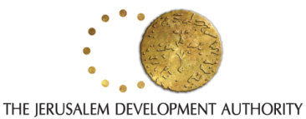
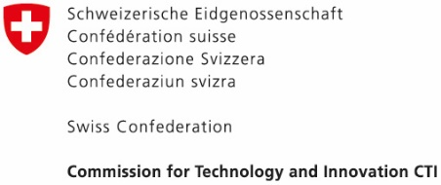
Welcome to Start JLM 2017!
We are glad you have decided to apply for the competition! The two-step selection process includes this application form providing us with the information required to assess your team and idea. After our initial screening, the most promising applicants will be invited to a pitching event in Bern on Monday, October 9, 2017, during which we will announce the winner. The winner will be invited to participate in the Start JLM program in Jerusalem from November 5 to November 11, 2017. The program’s costs are fully funded by the organizers, including one round-trip flight ticket and accommodation. This competition is organized by the Embassy of Israel to Switzerland in collaboration with the Swiss Federal Commission for Technology and Innovation (CTI).
Deadline for submission of applications – September 22, 2017, 24:00 CEST
Full Name*

Email Address*

Phone No.*

Name of Venture*

Link to Website

Postal Address*

Describe your venture / idea in a few words*

Please describe your project in a short video, provide the link here*

Which problem / need are you addressing or solving?*

How long have you been working on this project?*

How did you hear about the competition?*

Anything else we should know?

